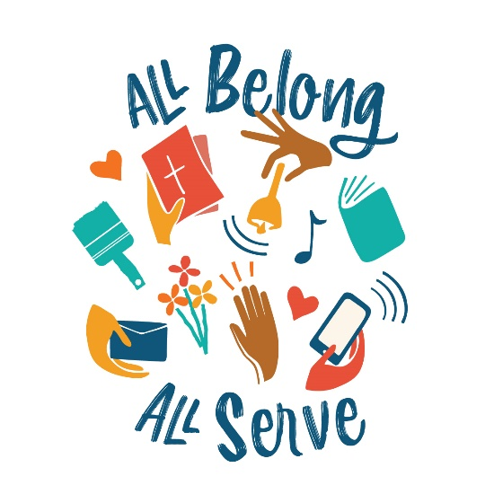
WELS Special Ministries Updates
Southeastern Wisconsin District Conference
June 2021

Don’t overlook these Christians’ spiritual gifts Does it seem like the same people get recruited for tasks at your church? Remember that the Spirit distributes gifts as He determines (1 Cor 12:11). Some spiritual gifts remain untapped if we classify people according to their disabilities and not according to their gifts. Inclusion is not just a modern buzzword; it’s how the body of Christ is functions best. Sometimes a hard of hearing person can be the spark of your evangelism committee, and a blind member can be your best connection to shut ins. People with special needs already belong to your church family. Equip them to serve! “All belong, all serve!” Ask Special Ministries how.

Public Library? In an era where everything is expensive, many people get their reading material for free from public libraries. Church libraries serve a similar function. The WELS Listen Library (listen.wels.net) gives free access to Lutheran audiobooks and articles for people who are blind or visually impaired. Meditations and Forward in Christ are available for free (yes, free!) for your visually impaired members. Your visually impaired or their families can subscribe by calling MVI (651-291-1536) or emailing welsvisimp@wels.net. MVI needs volunteers who have some ability to work on the Internet or can learn to sound edit. Most volunteers can work from home.

Online learning Throughout the year, Special Ministries teams offer excellent courses, often with financial aid. Starting in September you could take any of these online chaplaincy courses: Communicating Forgiveness, A Scriptural Approach to Addiction Counseling, Frontline Chaplaincy, Geriatric & Care Facility Ministry (free!) and “Grounded in Scripture” a doctrinal course for those interested in ministry but have not had a foundational study of Scripture. For more information, see the MLC website mlc-wels.edu/continuing-education/wels-chaplain-certificate/ or email chapcert@wels.net.

Vulnerable WELS members and others we love get incarcerated or face life and death situations in the military. Please provide Special Ministries with contact information for your members who are in the military or who are incarcerated. In less than a minute, you can connect a member who is not able to attend your church with WELS military ministry (wels.net/military) or prison ministry (wels.net/prison-ministry). Just go to wels.net/refer.

“Overwhelmed Parents” Sometimes people don’t ask for help, but the church family wonders if there is a way to help. For years, we offered families of children with special needs the help of the “Special Needs Family Network” but such parents rarely reached out for help. We have now replaced that program with Light for Parents. Organized by experienced parents of children with extraordinary needs, Light for Parents wants to guide church families in developing ways to respond in love and support for such families. Light for Parents also offers to mentor and be a resource for parents who face the daunting responsibilities of care for a child whose medical, physical or developmental challenges are significantly greater than usual. For more information see lightforparents.com

No time to equip that one member? Churches and schools have gotten better at providing skills and tools for leaders. Many Congregational Services resources are available for that kind of training. But what about the lone member with a heart for prison ministry or the concerned friend of a special needs family who wants to help? Special Ministries can help you equip church members for ministry by providing individuals with training. Prison Ministry is producing a course to mentor someone who has returned to the church or community after incarceration. Parish Nursing provides an opportunity for WELS members who are nurses to use their skills and training among God’s people. Conquerors through Christ provides resources for parents to teach their children godly sexuality and help them to respond appropriately when they encounter porn. Special Ministries is here to help you equip! Email specialministries@wels.net.

Faith comes through hearing – How would you translate that verse into sign language for the deaf? Is it physical hearing? While you wrestle with that question, consider this: a third of older church members have hearing loss – a significant number refuse to admit it. We want everyone in our churches (and tuning in online) to receive the gospel message, to experience the Spirit’s work, and to believe in Jesus. The Mission for the Deaf and Hard of Hearing continues to help congregations cross the “sound barrier” with the gospel! Whether it’s captioning, looping, interpreting or building bridges with the gospel, we can help you. Learn more at welscongregationalservices.net/mdhh/

Professional therapists needed Do you have an active church member who has training to be a therapist? We offer courses to train WELS members who are professional counselors, so they learn how to become Christian counselors. The number of Christian therapists has grown rapidly but cannot keep up with the demand. The WELS / ELS Christian Therapist Network exists to equip, encourage and strength WELS / ELS therapists as they serve God’s people. Find more information at christiantherapistnetwork.com.

Confirmation instruction and examination questions Are you looking for specialized materials and guidance for instructing someone in the faith, such as someone with developmental disabilities or an adult who is deaf? Special Ministries can help you find the right resource. Call Special Ministries at 414-256-3240.

Love in Action The beautiful booklet about Special Ministries did not get distributed during the pandemic. It is a guide to the many resources available to members and people in our communities. WELS members can see read it for themselves online at WELS.net/special-ministries.

Respectfully Submitted,
Pastor Richard Waldschmidt
SEW District Coordinator

