Professor Meilahn P. Zahn Memorial Scholarship for the Advancement of
Lutheran Worship in Christian Education
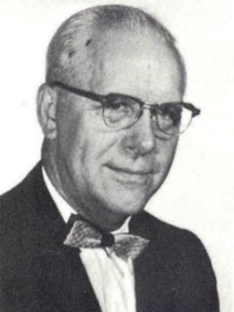

- The Zahn family established this scholarship fund in 2015 in memory of Professor Meilahn P. Zahn (1905-1982). He served at St. Peter-Fond du Lac WI, Grace-Oshkosh WI, Trinity-Menasha WI, and Michigan Lutheran Seminary before he was called to DMLC, where he directed the traveling choir, taught conducting class, and served as music department chair 13 of his 15 years (1962-1977).

- The scholarships supported by this fund benefit both the students who apply and the church at large. Because the fund is able to support annual scholarships in excess of $4000 to as many as three applicants, undergraduate students are motivated to apply by producing a work that promotes Lutheran Worship and/or Lutheran music education. The work may be musical, textual, visual, pedagogical, or technological. Work continues on creating a forum that makes the works available for use by the church at large.
- Awarded works include a strong hymn text usable especially for End Times and a collection of tympani accompaniments to all the hymns in Christian Worship.
- Should you desire, you can support the fund at:
https://community.mlc-wels.edu/mlc-responsive-scholarship-page
Professor Meilahn P. Zahn Memorial Scholarship for the Advancement of
Lutheran Worship in Christian Education

- The Zahn family established this scholarship fund in 2015 in memory of Professor Meilahn P. Zahn (1905-1982). He served at St. Peter-Fond du Lac WI, Grace-Oshkosh WI, Trinity-Menasha WI, and Michigan Lutheran Seminary before he was called to DMLC, where he directed the traveling choir, taught conducting class, and served as music department chair 13 of his 15 years (1962-1977).

- The scholarships supported by this fund benefit both the students who apply and the church at large. Because the fund is able to support annual scholarships in excess of $4000 to as many as three applicants, undergraduate students are motivated to apply by producing a work that promotes Lutheran Worship and/or Lutheran music education. The work may be musical, textual, visual, pedagogical, or technological. Work continues on creating a forum that makes the works available for use by the church at large.
- Awarded works include a strong hymn text usable especially for End Times and a collection of tympani accompaniments to all the hymns in Christian Worship.
- Should you desire, you can support the fund at:
https://community.mlc-wels.edu/mlc-responsive-scholarship-page

